Assignment 6. MLOps with AWS

# Project Setup

## Clone project repo:

I forked the original repo into my GitHub account ([repo link](https://github.com/MohmedMonsef/oxford-genai-llmops-project))

Then cloned it locally

git clone https://github.com/MohmedMonsef/oxford-genai-llmops-project.git

## A screenshot of a computer AI-generated content may be incorrect.Build the Dev Container

## Setup .env file

Create the .env file and complete missing environment variables related to OpenAI and Comet Opik

## Install dependencies

## Run the application

Inspect the server

# GitHub Actions

We have defined the following GitHub workflow to:

* Print the required message
* Install dependencies via poetry
* Run unit tests

name: CI Initialise

on:

    push:

      branches:

        - '**'

jobs:

    initialise:

        runs-on: ubuntu-latest

        steps:

            - name: Checkout code

              uses: actions/checkout@v4

            - name: Print CI message

              run: echo "CI step initialising"

            - name: Setup python

              uses: actions/setup-python@v5

              with:

                python-version: '3.12'

            - name: Install poetry

              run: |

                curl -sSL https://install.python-poetry.org | python3 -

                echo "$HOME/.local/bin" >> $GITHUB_PATH

            - name: Cache poetry dependencies

              uses: actions/cache@v4

              with:

                path: |

                    ~/.cache/pypoetry

                    ~/.cache/pip

                key: poetry-${{ runner.os }}-${{ hashFiles('**/poetry.lock') }}

                restore-keys: |

                    poetry-${{ runner.os }}-

            - name: Install dependencies

              run: |

                cd rag-app

                poetry install --no-root

            - name: Run pytest

              run: |

                cd rag-app

                echo "${{ secrets.DUMMY_ENV }}" > .env

                poetry run pytest

### Note

The tests provided in the original repo were buggy and did not pass. We solved these issues in [this](https://github.com/MohmedMonsef/oxford-genai-llmops-project/commit/892eb1897767ab4e43df1576d49e729538bdee22) commit.

Now, the tests are passing, and the CI workflow is running successfully.

# Database setup

## Build the database

Outside the dev container.

$ cd rag-app

$ make build-db

## Test the database is working correctly

You need to install requirements for psql and make sure the .env file is written correctly to be able to source it.

$ cd rag-app

$ source .env

$ psql -h localhost -U $POSTGRES_USER -d $POSTGRES_DB -p $POSTGRES_PORT

$ \dt

Output in the terminal

Also, we can test it is running via:

$ docker ps

Output in the terminal, you will find the postgres container running.

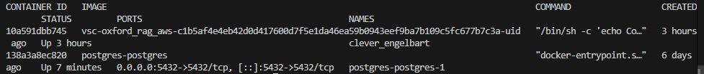

# Data Ingestion and Embedding

## Keyword for search

I have tried a different query keyword (llm) and downloaded the new data using

$ make download-data

Then ingest the data using

$ make run-ingestion

Make sure the rows are inserted in the database

$ psql -h localhost -U $POSTGRES_USER -d $POSTGRES_DB -p $POSTGRES_PORT

mydb=# SELECT count(*) FROM public.papers;

Output in the terminal:

Note, if you ran the ingestion twice, then you have inserted the 80 documents twice in the database. To clear the database and reset the auto-increment id, use the following command

$ psql -h localhost -U $POSTGRES_USER -d $POSTGRES_DB -p $POSTGRES_PORT

mydb=# TRUNCATE TABLE public.papers RESTART IDENTITY;

This will reset the database to have 0 rows, and to fill it again, ingest the documents once again.

Output in the terminal:

# RAG Workflows

top-k is forced in “LIMIT %s”, and the used limit is passed in “execute()” method

## Exercise questions

### a. What does top_k mean in this context (i.e., of RAG)?

top_k specifies the number of most relevant document chunks to retrieve from the database based on their similarity to the query embedding. It controls how many context passages are fed to the language model.

### b. What will happen if I increase or decrease top_k?

* **Increase top_k** → More documents retrieved, potentially more relevant context but slower performance and higher token cost. Also, too large k may add irrelevant context that may confuse the LLM.
* **Decrease top_k** → Fewer documents retrieved; faster and cheaper but might miss important context.

### c. What is the algorithm inside the database query and how does it work?

The algorithm is **cosine similarity** (implemented via the <=> operator in pgvector for vector types). It computes the angular distance between the query embedding and document embeddings:

* Cosine similarity = dot product of normalized vectors.
* Lower distance implies higher similarity.

### d. Why is the query to Postgres asking for results in ascending order?

Because the <=> operator returns **cosine distance**, not similarity — smaller values indicate closer (i.e., more similar) vectors. Sorting by ASC ensures the **most similar** chunks come first.

### There is an error control flow in the retrieve_top_k_chunks_endpoint that deals with a failure to retrieve chunks (i.e context). Under what scenarios could this happen?

Not sure about that, but some possibilities are:

* The papers table has no data
* Embeddings are missing or malformed
* The query embedding can't be compared (dimension mismatch)

### The process flow that happens when a user hits the “generate” endpoint with a query:

Steps:

* rag-app/server/src/controllers/generation.py => generate_answer_endpoint(…)
  + chunks = retrieve_top_k_chunks(query)
  + generated_response = generate_response(query, chunks)
* return generated_response

## Run the app

$ make run-app

Then navigate to <http://127.0.0.1:8000/docs>

You will find swagger docs

## Generate

Try the generation endpoint

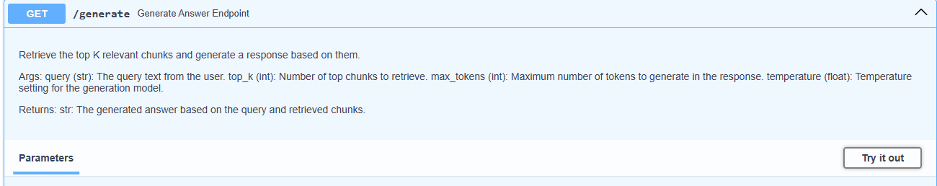

Insert your query and other parameters

Execute to get the response

## Frontend

You can do the same but with a front-end client

navigate to <http://127.0.0.1:8502/>, you will find streamlit app running

# Tracing and Tracking

### It is possible to run some logic upon the initialization of your FastAPI server that will persist specific objects or configurations throughout the lifetime of the session. Can you see where this is done in the server/src/main.py file? What has been initialized, why is this a good place to run these commands?

Yes, this is done inside the lifespan_context async function:

* **Where**: In server/src/main.py, it's done in the lifespan_context function.
* **What is initialized**:
  + opik.configure() — a global config setup
  + embedding_model = SentenceTransformer("all-MiniLM-L6-v2") — a sentence embedding model loaded once into memory.
* **Why is it a good place**:
  + The lifespan context is the **ideal place for startup logic** because it's run **only once** when the server starts (not on every request), making it efficient for heavy initialization like loading models.
  + It also allows proper **cleanup** at shutdown via the “finally” block.
  + Keeping models in memory here allows **reusing expensive resources** without reloading them per request, improving performance and scalability.

### Add some tracking and tracing to other services and functions in the application. Check that these are successfully logged into your Opik instance in the online portal.

We Tracked the get_db_connection(…) function

It is successfully tracked in opik

Also, other functions are being tracked

### Online Evaluation

Created a custom evaluation metric

And check it is running

